**­Quiz 8**

**DSCI 558 BUILDING KNOWLEDGE GRAPH**

Name: ________________________________________________

## Question 1 (6pts)

Fill in the blanks using the following terms: item, property, value, statement, statement value, qualifier

1. Item
2. Property
3. Statement
4. Value
5. Qualifier
6. Statement Value

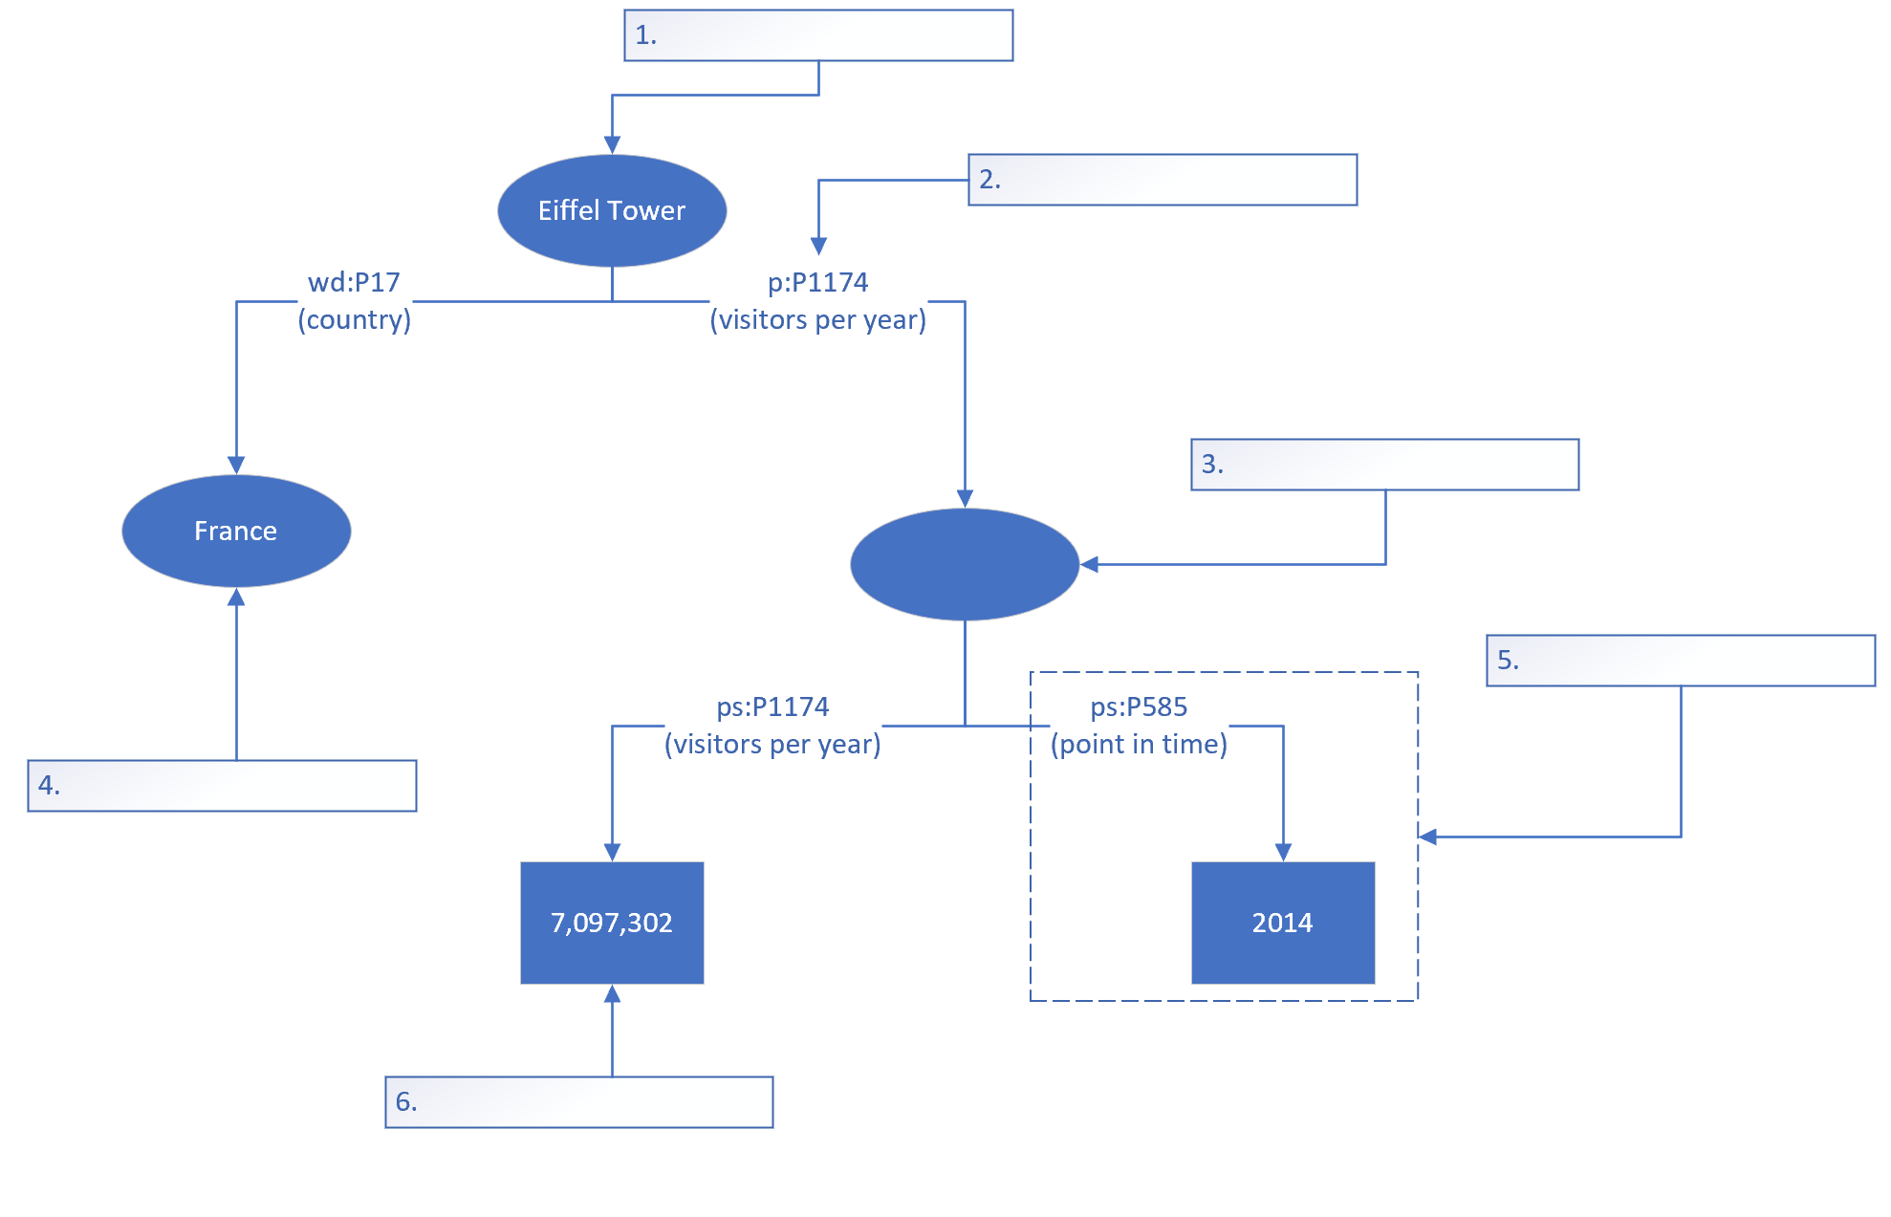

## Question 2 (4pts)

Map the following challenges to their corresponding entity linking steps

1. Name Variations: Candidate Generation
2. Huge Knowledge Graph Volume: Candidate Generation
3. Entity Ambiguity: Candidate Ranking
4. Entity Absence: Unlinkable Mention Prediction